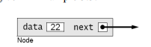
class Node {
int data;
Node next;
Node(int data) {
this.data = data;
}
}
Constructing a Linked List
Node start = new Node(22);
start.next = new Node(33);
start.next.next = new Node(44);
start.next.next.next = new Node(55);
start.next.next.next.next = new Node(66);
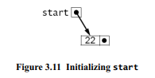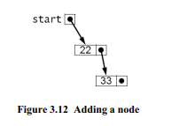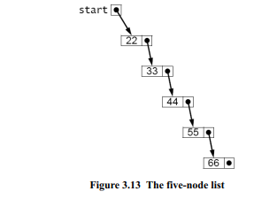

Node p;
Node p=start;
p = p.next;
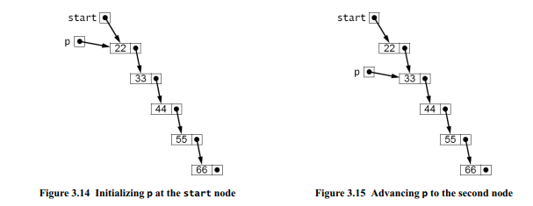
p = p.next;
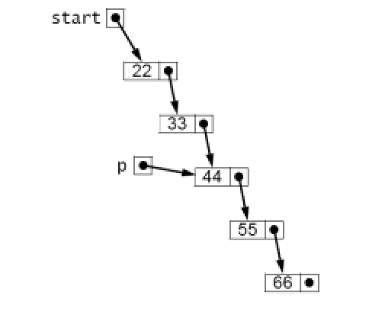

Constructing a Linked List
1 start = new Node(22);
2 Node p=start;
3 p.next = new Node(33);
4 p = p.next;
5 p.next = new Node(44);
6 p = p.next;
7 p.next = new Node(55);
8 p = p.next;
9 p.next = new Node(66);

This code may not seem much better But one big advange is that
it is easily managed within a loop.

Using a for Loop
Node start = new Node(22), p = start;
for (int i=0; i<4; i++) {
p = p.next = new Node(33+11*i);
}

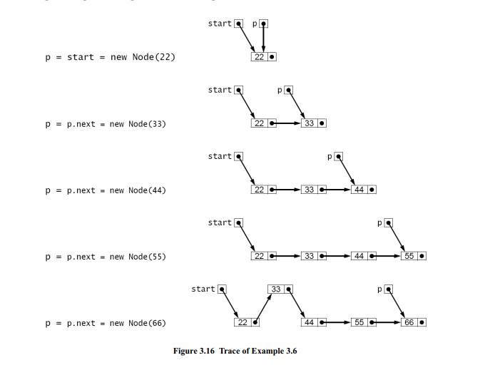

Using a for Loop to Print a Linked List
for (Node p = start; p != null; p = p.next) {
System.out.println(p.data);
}
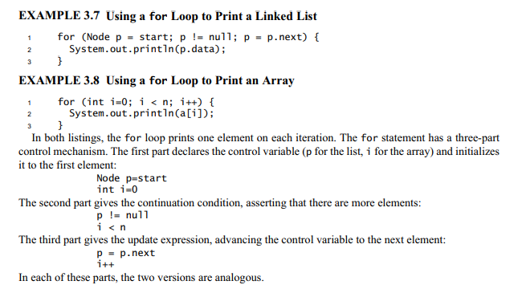
Testing the Node Class

class Node {
int data;
Node next;
Node(int data) {
this.data = data;
}
}
public class TestNode {
public static void main(String[] args) {
Node start = new Node(22);
Node p = start;
for (int i = 1; i < 5; i++) {
p = p.next = new Node(22 + 11*i);
}
for (p = start; p != null; p = p.next) {
System.out.println(p.data);
}
for (p = start; p != null; p = p.next) {
System.out.println(p);
}
}
}
start.next.next.next.next.

